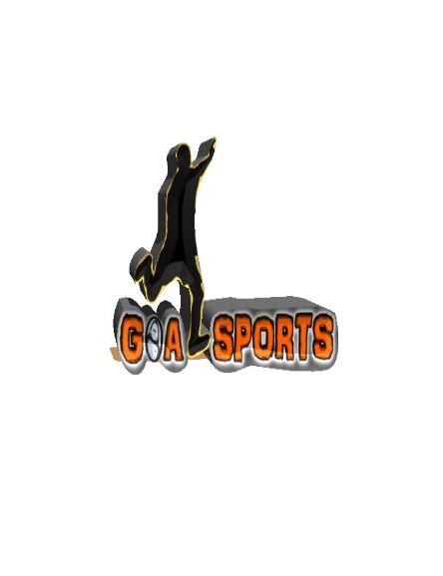
Goal Sports Respect Code of Conduct
Updated September 2023
The following values are as vital as the most basic football skills we teach at Goal Sports.
These are my four top values:
- Mutual respect between child and coach
- Discipline
- Understanding
- Team spirit
You, the football coach, are part of a child’s life and will have an effect on helping youngsters develop into fair and sporting players and athletes.
At Goal Sports all have a part to play. We all bear a collective responsibility to set a good example and help provide a positive environment in which children can learn and enjoy the game.
Play your part and observe The Goal Sports Code of Conduct at all times.
On and off the coaching field, I will:
- Use my position to set a positive example for the people I am responsible for
- Show respect to others involved in the game/session including match officials, all players, Goal Sports staff, School Staff, Parents and spectators.
- Adhere to the laws and spirit of the game
- Promote Fair Play and high standards of behaviour
- Respect the match official’s decision – Promote this within your session.
- Never engage in, or tolerate, offensive, insulting or abusive language or behaviour between children/staff/parents/spectators.
- Be aware of the potential impact of bad language and/or behaviour on other participants, parents and school staff.
- Encourage & discuss how players should be gracious in victory and defeat

When working with players, I will
- Place the well-being, safety and enjoyment of each player above everything, including winning
- Never engage in or tolerate any form of bullying
- Ensure all activities I organise are appropriate for the players’ ability level, age and maturity
- Co-operate fully with others at your sessions (e.g. Other staff, School staff, Parents) for each player’s best interests
- Use my position to remind players and or parents of the Goal Sports Respect Code of Conduct should I feel the need to do so.
I understand that if I do not follow the Code, any/all of the following actions may be taken by Goal Sports
I may be:
- Required to meet with management and or school representatives to discuss matters arising.
- Suspended from coaching at a session in which an issue has arisen
- Required to leave or be sacked from Goal Sports in the event of gross misconduct of the respect code of conduct.
Respect Code of Conduct – Staff Signatures
Name : Signature:________________Date___
Name : Signature:________________Date___
Name : Signature:________________Date___
Name : Signature:________________Date___
Name : Signature:________________Date___

